To: Department of Student Affairs
Name of Society/Club: Yoga Society Code No.: __________________ Date: 4 / 7 / 2025
I have pleasure in submitting a list of our office bearers for the term of office effective from 1/7/2025 to 30/6/2026 as required by your department. They were elected during our Annual General Meeting held on 4/7/2025.
Designation | Name | Student ID. | Course | Year | Email Address | Contact No. | Signature
Chairperson | Pong En Ni | 2207210 | QS | Y2S3 | anny1216@1utar.my | 011-37596228 | 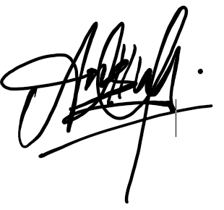
Vice Chairperson | Lam Mun E | 2203464 | QS | Y2S2 | pen9mune@1utar.my | 016-6180773 | 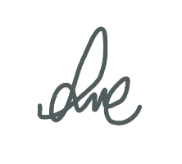
Secretary | Geogina Adrianna Stalin Jerah | 2204481 | IB | Y2S3 | gina04@1utar.my | 012-2139836 | 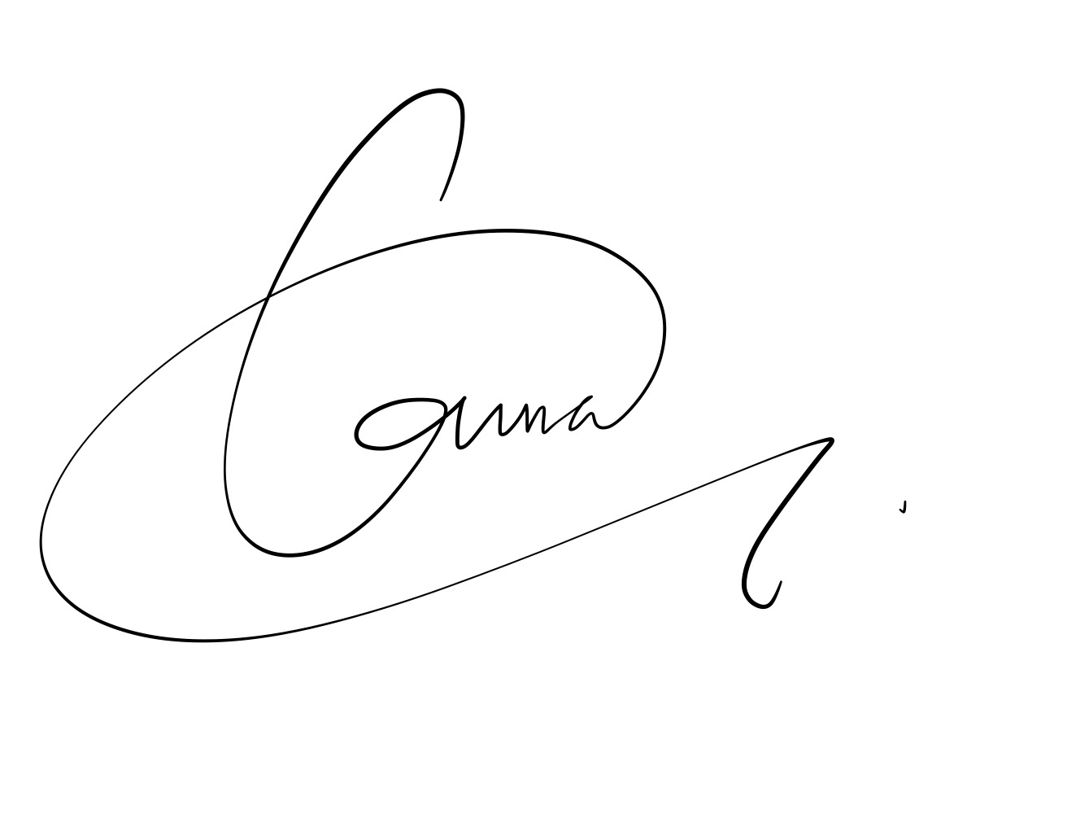
Treasurer | Tarveen Kaur A/P Jura Singh | 2405678 | NS | Y1S3 | tarveen01@1utar.my | 011-23378072 | 
Publicity | Chong Ming Yue | 2304069 | AS | Y2S3 | cmingyue2003@1utar.my | 014-9337563 | 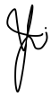
Committee Member | Seah Jun Wei | 2206981 | SE | Y2S3 | seahzy1@utar.my | 014-6690533 | 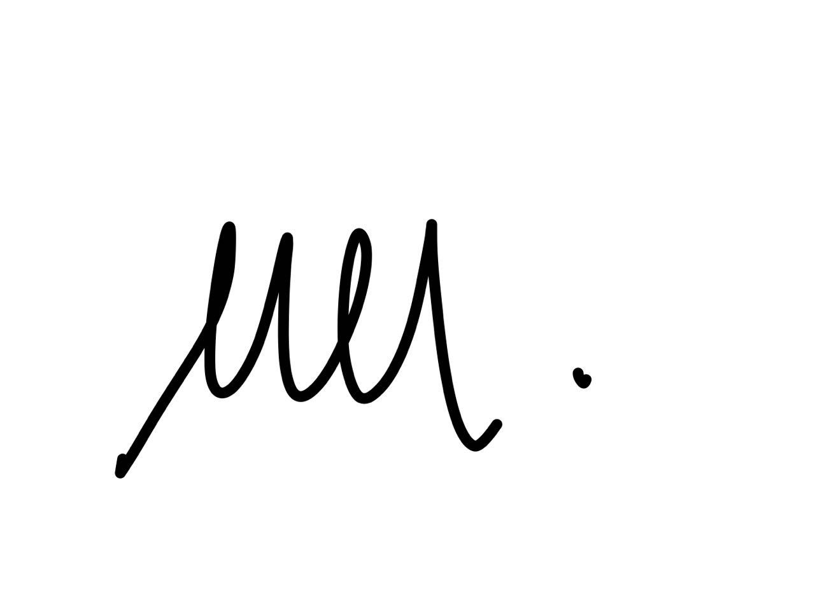
Committee Member | Gan Yi Zhe | 2206733 | AS | Y2S3 | yizhegan28@1utar.my | 013-4399939 | 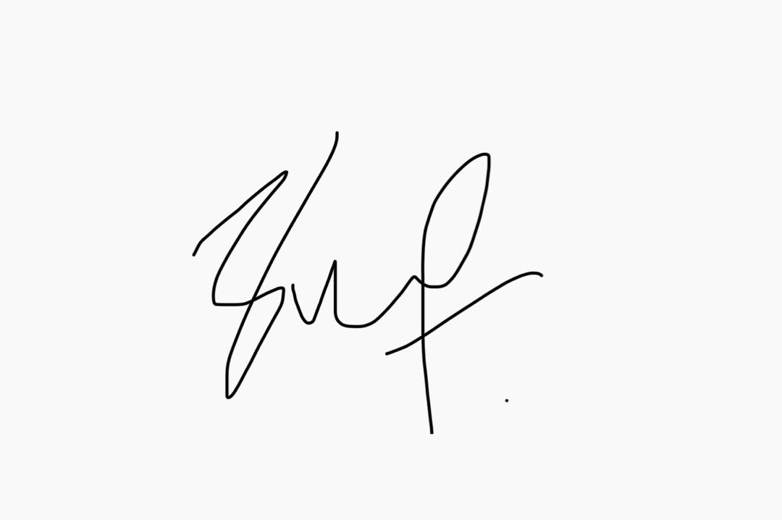
Auditor | Vivian Tang Yen Ai | 2104664 | AT | Y2S3 | vivian.tang233@1utar.my | 016-3013777 | 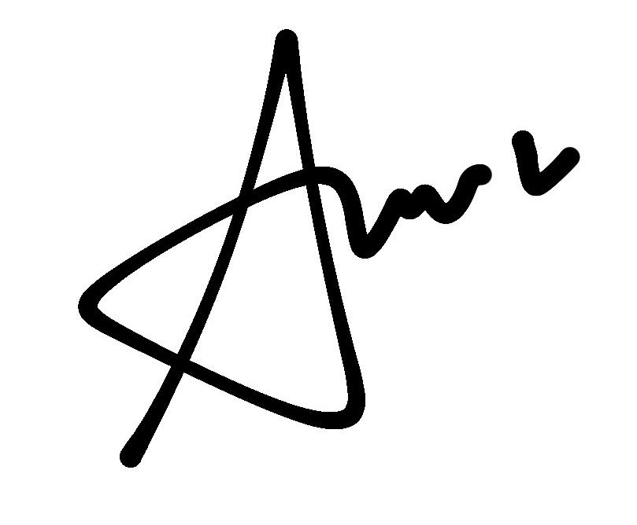

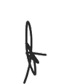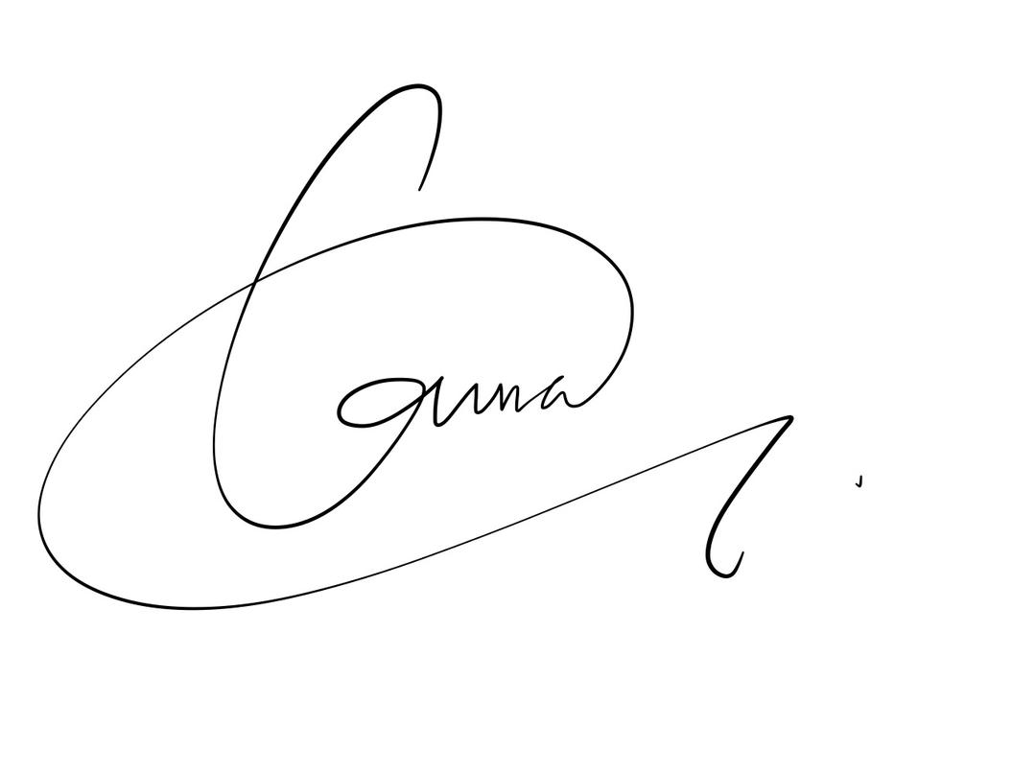

_______________________________________________ ________________________________________________
Signature Signature

Name of Adviser: MS HENG SZE LU Name of Honorary Secretary: GEOGINA ADRIANNA STALIN JERAH

Verified By, Approved By,

___________________ ___________________
Ms Belinda Ms Choong Yee Chin
Assistant Manager/ Manager/ Senior Manager
Senior Assistant Manager Department of Student Affairs
Department of Student Affairs Date:
Date:

